
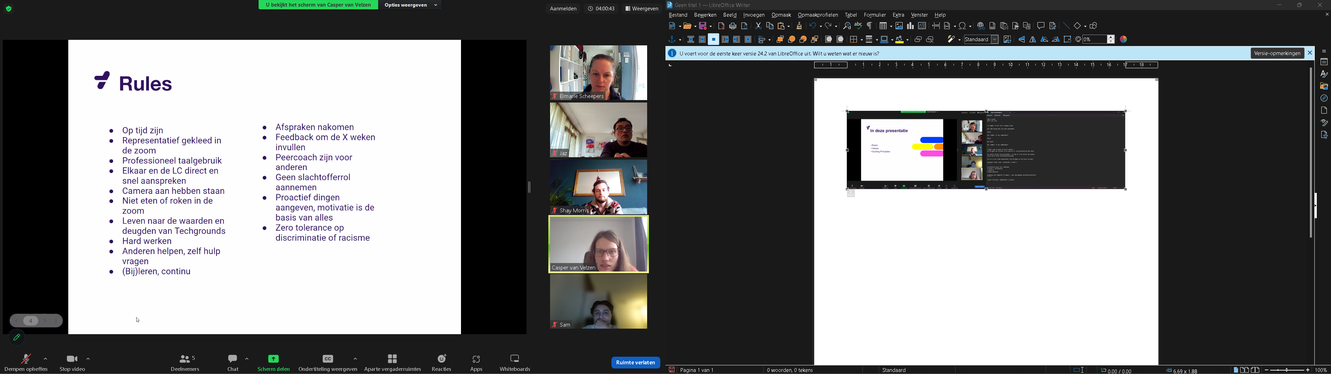
-

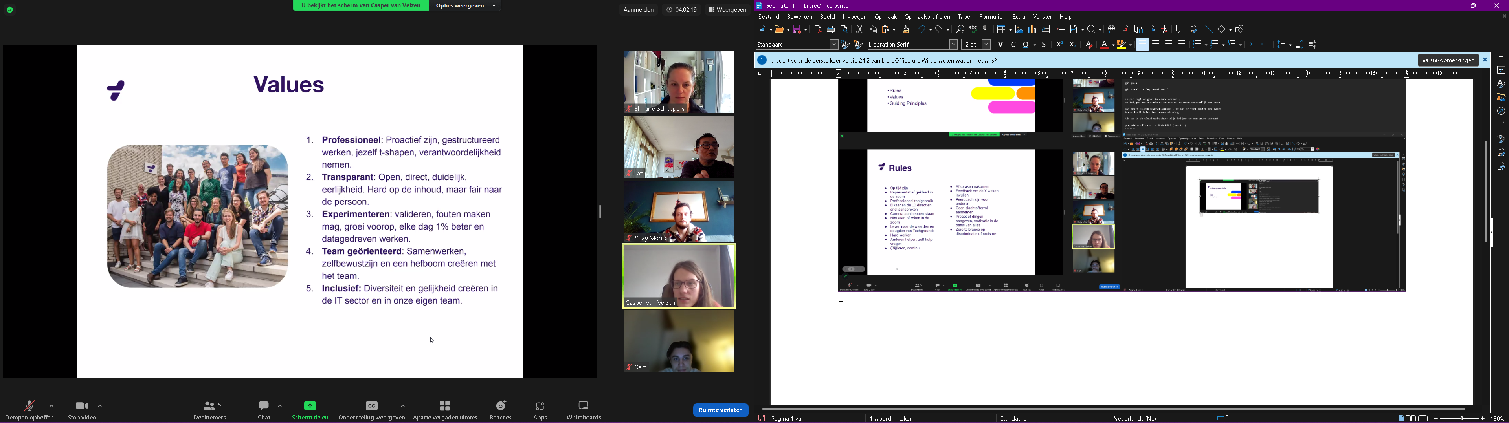
-
https://www.linkedin.com/pulse/guiding-principles-mike-martin#:~:text=Guiding%20Principles%20are%20your%20personal,and%20in%20how%20we%20lead.
Guiding Principles are your personal values and beliefs. These values and beliefs tend to influence you (us) in the decisions we make and in how we lead.

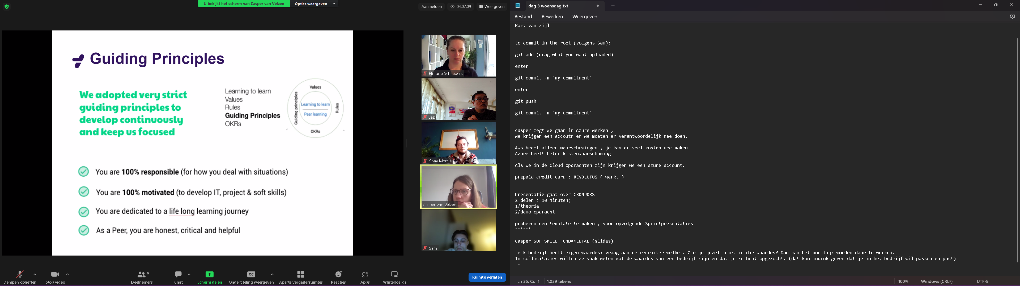
-
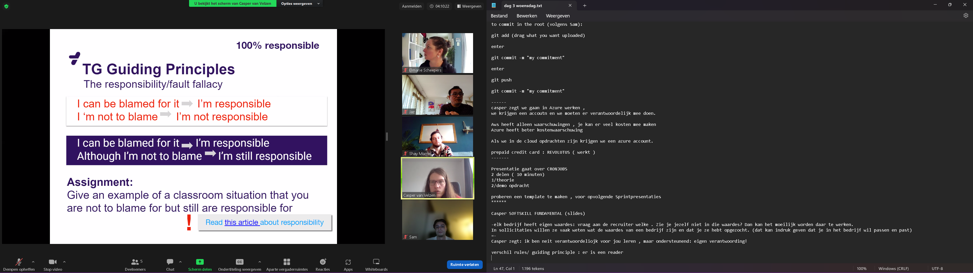
-

-
Personal OKRs adopt a model that focuses on helping employees decide what they must do to improve themselves. It doesn't fully enhance personal development or career growth or align with the company's goals. Team OKRs adopt a model that involves every team employee working to meet the company's goals.




